Dheeraj R K, Harsha Vardhan M A, Mahantesh and Dr. Shylaja SS

Department of Information Science and Engineering

PES Institute of Technology, Bengaluru, India

A Comparison of Haar-Cascade classifier and Linear Binary Pattern classifier in face recognition.

**Abstract**— Face recognition and authentication are two significant and vigorous research issues in computer vision applications such as military, secure control and crime prevention systems. There are many factors that should be accounted for face Recognition.

Apart from improvements of existing techniques for better performance and less processing power, statistical analysis of existing techniques is also necessary to equip enthusiasts with the best method available. This paper is an attempt to compare the two famous classifiers namely, Haar cascade and Linear Binary Pattern. Algorithms of both these techniques are tested for their accuracy (using a specific number of images) in recognising faces. All face images used were subjected for pre-processing to remove noise and converting them into grey-scale. Later on, both these image classifying techniques are analysed and it was evident from the observations that Linear Binary Pattern classifier was having a better accuracy than the Haar-Cascade classifier.

*Key Points*—***Haar cascade classifier, linear binary pattern classifier, feature detection, feature description.***

1. INTRODUCTION

Object Detection using Haar feature-based cascade classifiers is an effective object detection method proposed by Paul Viola and Michael Jones in their paper, "Rapid Object Detection using a Boosted Cascade of Simple Features" in 2001. It is a machine learning based approach where a cascade function is trained from a lot of positive and negative images. It is then used to detect objects in other images.

**Local Binary Pattern**(LBP) is a simple yet very efficient texture operator which labels the pixels of an image by thresholding the neighbourhood of each pixel and considers the result as a binary number. Due to its discriminative power and computational simplicity, LBP texture operator has become a popular approach in various applications. It can be seen as a unifying approach to the traditionally divergent statistical and structural models of texture analysis. Perhaps the most important property of the LBP operator in real-world applications is its robustness to monotonic gray-scale changes caused, for example, by illumination variations. Another important property is its computational simplicity, which makes it possible to analyze images in challenging real-time settings.

1. OVERVIEW

This paper encounters the required objective in many sections named after Roman numerals. Section III deals with the pre-processing steps of the image and the subsequent sections will emphasise on the implementation details of the

project which is added with statistical figures to support the conclusion derived from the result, in the last section.

1. IMAGE PREPROCESSING

This section emphasises on the steps performed before the data sets (that is the images considered) are fed into the classifier algorithms.

1. *Obtaining dataset*

The face dataset collected for testing the above stated classifiers were mostly downloaded from the internet.

For Haar cascade classifier, random image data set of celebrities are downloaded, and for Linear Binary Pattern classifier, the Yale Face Database is used.

1. *Tool used*

The tool used for pre-processing, testing and training of images on classifiers is performed using OpenCV packages with python bindings.

1. *Cropping of face images in the dataset*

The first stage of pre-processing wherein, only the required face part of the entire image is considered for various computations.

1. *Removing noise from images*

Noise, which is the unwanted content present throughout the image is removed in this step using existing noise removal techniques.

1. *Converting the image into grey-scale*

Conversion of RGB to grayscale is done by the python-opencv built in command.

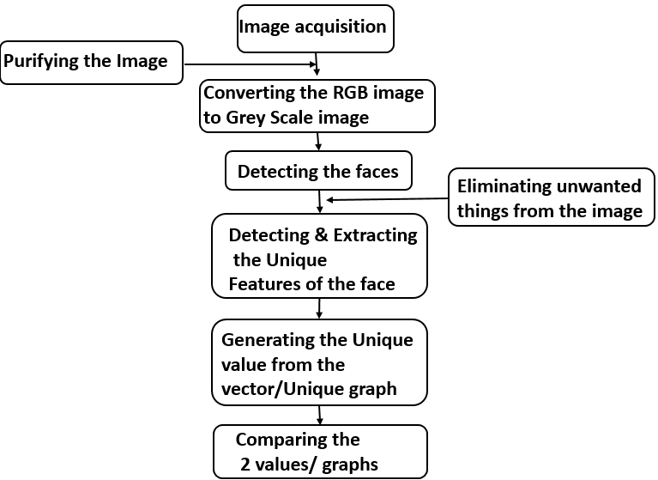

1. ANALYSIS OF HAAR-CASCADE CLASSIFIER

Object Detection using Haar feature-based cascade classiﬁers is an effective object detection method proposed by Paul Viola and Michael Jones in their paper, “Rapid Object Detection using a Boosted Cascade of Simple Features” in 2001. It is a machine learning based approach where a cascade function is trained from a lot of positive and negative images.

It is then used to detect objects in other images. The dataset used here is the random images of celebrities downloaded from the internet from various sites. 75 images are considered in the dataset, and the images are 200 X 200 pixels in dimension on an average. 3 to 4 different images of the same celebrity are collected.

1. *Analysing face images based on some features of image*

Vectors derived from matrices associated eyes, nose and mouth are considered to compare two face images, in this section. When an image is fed into the Haar-cascade classifier, vectors associated with eyes, nose and mouth of every image is obtained. Comparison of two images can be achieved by comparing the constituent matrices of eyes, nose and mouth associated with both the face images compared. Thus comparison is achieved by computing the Euclidian distance of vectors of eyes, nose and mouth of each similar pair of face images considered.

Threshold values of Euclidian distances of face component vectors of two face images considered are considered according to the redundancy of the values obtained and such other factors. As a result, threshold Euclidian distance of values of eyes, nose and mouth are obtained as 74, 35 and 99 respectively. Other details of this step are shown in the table below. Apart from images distinguished under true positive and false positives, the rest of the images out of 75 are under false positives or false negatives.

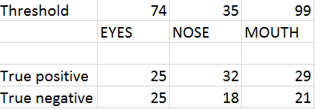

*B ) Analysing face images as a whole*

Contrary to the process explained above, this section considers the image as a whole using a mathematical process to combine the vectors of eyes, nose and mouth inorder to obtain a single vector to compare images. In this process, eyes, nose and mouth vectors are computed and they are given as elements of a 2 X 2 matrix. The other vacant space of the matrix is filled with 1 and the determinant is compared with the determinant of similar matrix of the similar image used for analysis.

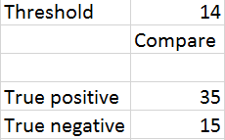

The results of the Haar-cascade classifier obtained as depicted above for vectors of entire face images. It is evident from the both the tables in section A and section B that, both the sections give similar kind of accuracy (Euclidian distances of one of the three features considered for a particular image is close to the face vector in section B) which is around 62%.

Analysis of LBP is given the succeeding section.

1. ANALYSIS OF LINEAR BINARY PATTERN CLASSIFIER

Local Binary Pattern is a simple efficient texture operator which labels the pixels of an image by thresholding the neighbourhood of each pixel and considers the result as a binary number.

We use the LBP texture descriptors to build several local descriptors of the face and combine them into a global descriptor. These local feature based methods are most robust against variations in pose or illuminations than holistic methods. The facial image is divided into local regions and LBP texture descriptors are extracted from each region independently. The descriptors are then concatenated to form a global description of the face.

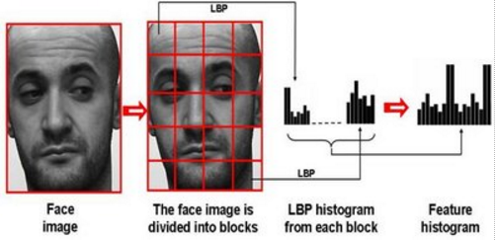

This histogram effectively has a description of the face on three different levels of locality: the LBP labels for the histogram contain information about the patterns on a pixel-level, the labels are summed over a small region to produce information on a regional level and the regional histograms are concatenated to build a global description of the face.

We have given 12 images of each person, 11 with different emotions, and 12th one with sad emotion. Like this we have given 70 peoples images. These 12th images will be checked with every person’s image.

Hypothesis table showing the result of L

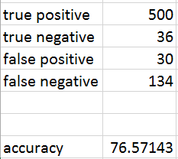

Hypothesis table of LBP

VI. RESULTS

Snapshots of sample images depicting output of both the techniques has been shown below.

1. *Haar-Cascade classifier*

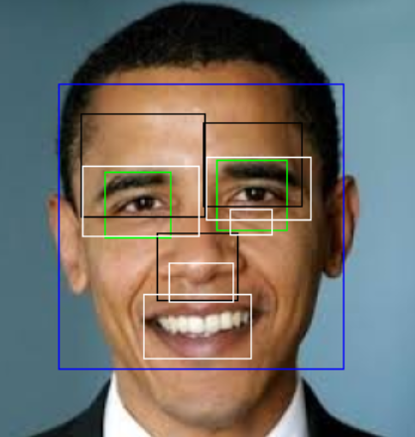 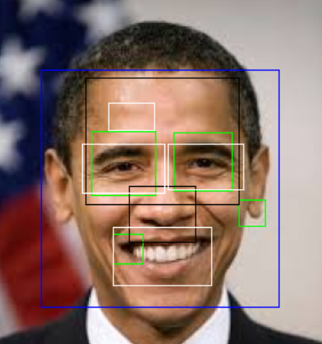

Image 1 Image 2

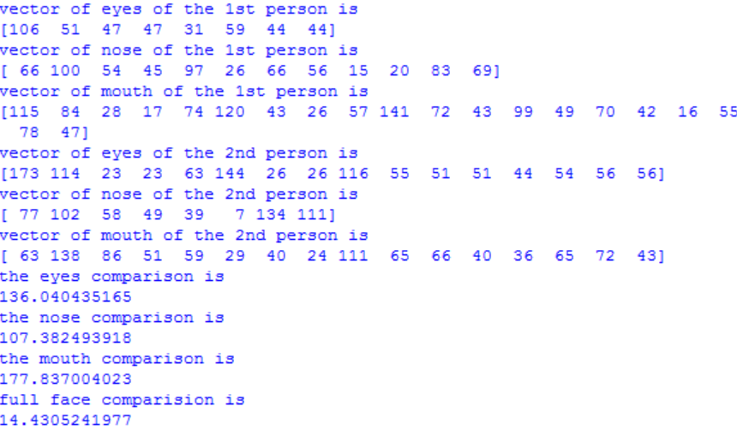

1. *Local Binary Patterns Histogram*

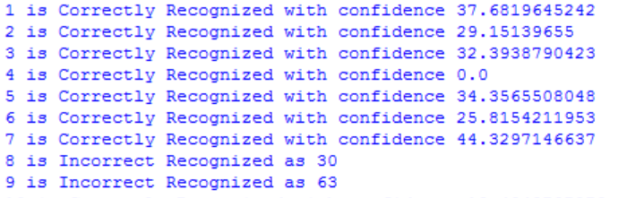

Overall accuracy comparision of both the techniques used is tabulated below.

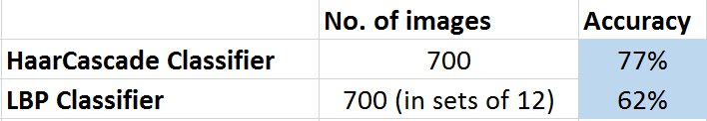

II. CONCLUSION & FUTURE WORK

It is evident from the preceding sections that the Linear Binary Pattern Classifier has more accuracy than Haar-cascade Classifier (77% and 62% respectively).

Therefore, Linear Binary Pattern Classifier is better in most cases when compared to Haar-cascade classifier.

To capture live images from webcam and recognize it.

To improve the efficiency of the test.

To Speed up the recognizer.

IX. REFERENCES

Opencv-python docs

1. http://docs.opencv.org/2.4/doc/tutorials/objdetect/cascade_classifier/cascade_classifier.html
2. <http://docs.opencv.org/3.0-beta/doc/py_tutorials/py_feature2d/py_orb/py_orb.html>
3. <http://docs.opencv.org/3.0-beta/doc/py_tutorials/py_feature2d/py_orb/py_orb.html>
4. <http://www.scholarpedia.org/article/Local_Binary_Patterns>
5. <https://en.wikipedia.org/wiki/ORB_(feature_descriptor)>
6. <http://www.sciencedirect.com/science/article/pii>
7. https://globaljournals.org/GJCST_Volume13/1-Face-Recognition-using-Local.
8. ["The Mathematics of Face Recognition"](http://siam.org/news/news.php?id=309) - by R.Kimmel and G.Sapiro.
9. ["How Facial Recognition Systems Work"](http://computer.howstuffworks.com/facial-recognition.htm) – by Bonsor.K.
10. **Discriminant analysis of principal components for face recognition** – by W. Zhao, A. Krishnaswamy, R. Chellappa, D. Swets and J. Weng
11. **Local Binary Patterns as an Image Preprocessing for Face Authentication – by**G. Heusch, Y. Rodriguez, and S. Marcel*.*
12. Face recognition under varying lighting conditions using self quotient image – byH. Wang, S.Z. Li and Y. Wang.
13. **Local Gabor binary pattern histogram sequence (LGBPHS) – by** W. Zhang, S. Shan, W. Gao, X. Chen and H. Zhang*.*
14. Human face recognition from a single front view – by Chen, C.W. and Huang, C.L. (1992).